HTML Introduction

[« Previous](http://www.w3schools.com/html/default.asp)

[Next Chapter »](http://www.w3schools.com/html/html_editors.asp)

What is HTML?

HTML is a **markup** language for **describing** web documents (web pages).

* HTML stands for **H**yper **T**ext **M**arkup **L**anguage
* A markup language is a set of **markup tags**
* HTML documents are described by **HTML tags**
* Each HTML tag **describes** different document content

HTML Example

A small HTML document:

<!DOCTYPE html>  
<html>  
<head>  
<title>Page Title</title>  
</head>  
<body>  
  
<h1>My First Heading</h1>  
<p>My first paragraph.</p>  
  
</body>  
</html>

[Try it yourself »](http://www.w3schools.com/html/tryit.asp?filename=tryhtml_intro)

Example Explained

* The **DOCTYPE** declaration defines the document type to be HTML
* The text between **<html>** and **</html>** describes an HTML document
* The text between **<head>** and **</head>** provides information about the document
* The text between **<title>** and **</title>** provides a title for the document
* The text between **<body>** and **</body>** describes the visible page content
* The text between **<h1>** and **</h1>** describes a heading
* The text between **<p>** and **</p>** describes a paragraph

Using this description, a web browser can display a document with a heading and a paragraph.

HTML Tags

HTML tags are **keywords** (tag names) surrounded by **angle brackets**:

<tagname>content</tagname>

* HTML tags normally come **in pairs** like <p> and </p>
* The first tag in a pair is the **start tag,** the second tag is the **end tag**
* The end tag is written like the start tag, but with a **slash** before the tag name

|  |  |
| --- | --- |
| **Note** | The start tag is often called the **opening tag**. The end tag is often called the **closing tag**. |

Web Browsers

The purpose of a web browser (Chrome, IE, Firefox, Safari) is to read HTML documents and display them.

The browser does not display the HTML tags, but uses them to determine how to display the document:

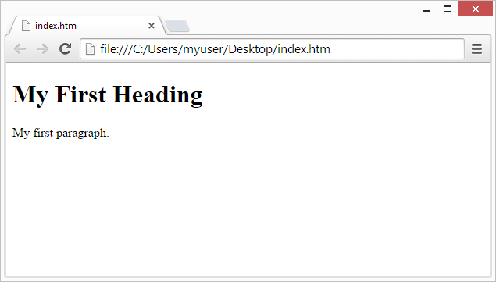

HTML Page Structure

Below is a visualization of an HTML page structure:

<html>

<head>

<title>Page title</title>

</head>

<body>

<h1>This is a heading</h1>

<p>This is a paragraph.</p>

<p>This is another paragraph.</p>

</body>

</html>

|  |  |
| --- | --- |
| **Note** | Only the <body> area (the white area) is displayed by the browser. |

The <!DOCTYPE> Declaration

The <!DOCTYPE> declaration helps the browser to display a web page correctly.

There are different document types on the web.

To display a document correctly, the browser must know both type and version.

The doctype declaration is not case sensitive. All cases are acceptable:

<!DOCTYPE html>  
  
<!DOCTYPE HTML>  
  
<!doctype html>  
  
<!Doctype Html>

Common Declarations

HTML5

<!DOCTYPE html>

HTML 4.01

<!DOCTYPE HTML PUBLIC "-//W3C//DTD HTML 4.01 Transitional//EN" "http://www.w3.org/TR/html4/loose.dtd">

XHTML 1.0

<!DOCTYPE html PUBLIC "-//W3C//DTD XHTML 1.0 Transitional//EN" "http://www.w3.org/TR/xhtml1/DTD/xhtml1-transitional.dtd">

|  |  |
| --- | --- |
| **Note** | All tutorials and examples at W3Schools use HTML5. |

HTML Basic Examples

[« Previous](http://www.w3schools.com/html/html_editors.asp)

[Next Chapter »](http://www.w3schools.com/html/html_elements.asp)

Don't worry if these examples use tags you have not learned.

You will learn about them in the next chapters.

HTML Documents

All HTML documents must start with a type declaration: **<!DOCTYPE html>**.

The HTML document itself begins with **<html>** and ends with **</html>**.

The visible part of the HTML document is between **<body>** and **</body>**.

Example

<!DOCTYPE html>  
<html>  
<body>  
  
<h1>My First Heading</h1>  
  
<p>My first paragraph.</p>  
  
</body>  
</html>

[Try it Yourself »](http://www.w3schools.com/html/tryit.asp?filename=tryhtml_basic_document)

HTML Headings

HTML headings are defined with the **<h1>** to **<h6>** tags:

Example

<h1>This is a heading</h1>  
<h2>This is a heading</h2>  
<h3>This is a heading</h3>

[Try it yourself »](http://www.w3schools.com/html/tryit.asp?filename=tryhtml_basic_headings)

HTML Paragraphs

HTML paragraphs are defined with the **<p>** tag:

Example

<p>This is a paragraph.</p>  
<p>This is another paragraph.</p>

[Try it yourself »](http://www.w3schools.com/html/tryit.asp?filename=tryhtml_basic_paragraphs)

HTML Links

HTML links are defined with the **<a>** tag:

Example

<a href="http://www.w3schools.com">This is a link</a>

[Try it yourself »](http://www.w3schools.com/html/tryit.asp?filename=tryhtml_basic_link)

The link's destination is specified in the **href attribute**.

Attributes are used to provide additional information about HTML elements.

HTML Images

HTML images are defined with the **<img>** tag.

The source file (**src**), alternative text (**alt**), and size (**width** and **height**) are provided as **attributes**:

Example

<img src="w3schools.jpg" alt="W3Schools.com" width="104" height="142">

[Try it yourself »](http://www.w3schools.com/html/tryit.asp?filename=tryhtml_basic_img)